**General Chemistry LabII-1112L**

# Lab Report#___6___

Student Name, Department of Chemistry and Biochemistry, Lamar University, Beaumont TX 77710

**Title- Rate Law Determination**

**Objective**- Explore the rate law while finding out the rate law of a specific reaction using experimental values we got in the lab.

**Procedure-** 1. First we set up our instruments (the LabQuest, temperature probe, and the pressure tube), got a beaker we called the waste beaker, and filled two other beakers with 250mL water

2. We gathered out other two solutions (or one a solute and the other a solvent). This included calculating the necessary grams required for a .5 M KI solute, as well as measuring out 3 4mL test tubes of H2O2 h

3. Next, we started the reaction. We quickly added the solute into the solvent, started the recording, and waited (and held the stopper in place) for 180 seconds.

4. We repeated this procedure for all solution, which (I failed to mention ahead) included the combination of .5 M KI with 3% H2O2 (the first procedure), .25 M KI with 3% H2O2 (the second procedure), and .5 M KI with 1.5% H2O2 .

**Data and Results**

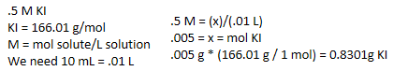

This is how we found the grams needed for .5 M of KI, we just divided it by half for .25 M.

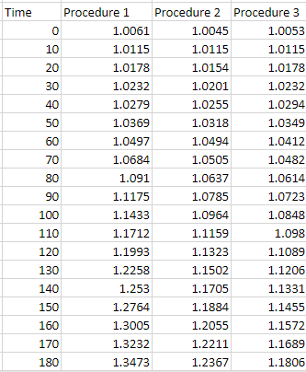

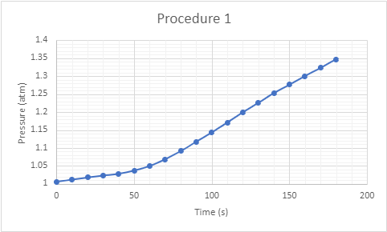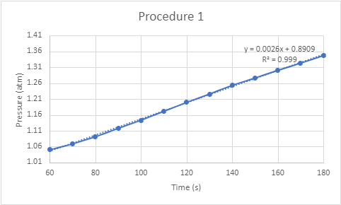

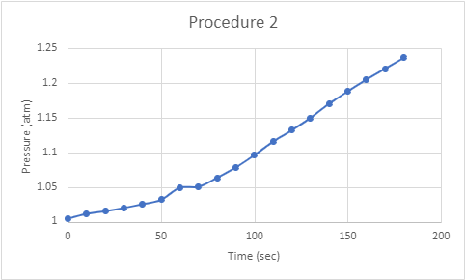

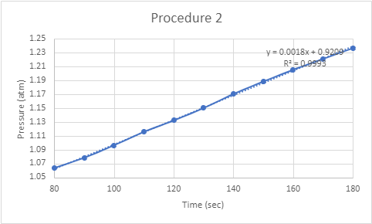

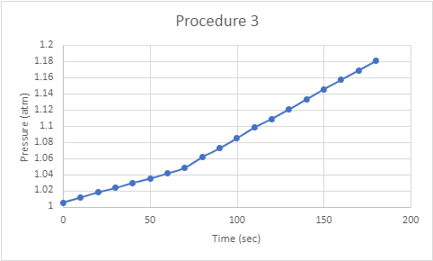

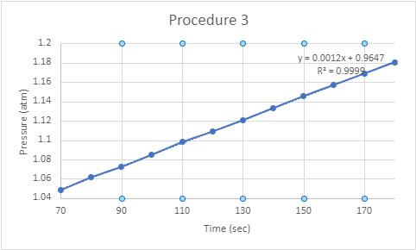

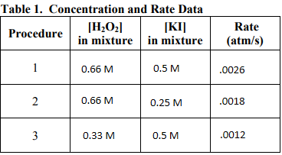

The slopes of each of the procedure graphs are the rates of the reactions.

**Conclusions**

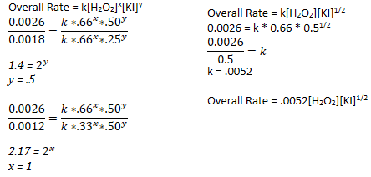

In conclusion, we can find out the rate of the reaction through a few experiments. There are three primary experiments that we must have, one with simple concentrations of the solute and solvent, one with a change in the concentration of the solute, and one with a change in the concentration of the solvent. The work above shows the final steps of getting from the table in my work, to the close reaction rate.

**Key Questions- Answer** all key questions in your lab manual and place them here.

1. Your team will be studying the reaction rate. What is meant by a reaction rate? - How fast the reaction takes place, or how fast the reactants disappear and the products appear.

2. What units does your team expect a reaction rate to have if the reactants are in solution and react in less than an hour? In less than 5 minutes? - Less than an hour would be in minutes, and less than 5 minutes would be in seconds.

3. What is the general rate law for this reaction using x for the order with respect to hydrogen peroxide and y for the order with respect to potassium iodide? -

Overall Rate = k[H2O2]x[KI]y

4. What is the molarity of hydrogen peroxide in 3% solution? - 0.66 M

5. What is the molarity of hydrogen peroxide in a 1.5% solution? - 0.33 M

6. How can a 1.5% solution of hydrogen peroxide be prepared from a 3% solution? - Using exactly half the amount of hydrogen peroxide for the same volume of the solution or adding twice the amount of water in the solution.

7. What mass of KI is required to to prepare 10 mL of 0.50 M KI? Why would this question be asked? - 0.8301 g

8. In preparing a 0.50 M KI solution, should 10 mL of water be added to the solid KI, should the solid KI be added to 10 mL of water, or should water be added to the solid KI until a total volume of 10 mL is obtained? Why? - Water to the solute, adding solute to the water would increase the volume of the solution.

9. Which line will provide the slope of the steepest part of the curve? - The blue line, the picture is in the lab guide.

10. How can a solution of a given concentration be diluted to prepare a solution of half that concentration? - You can add twice the amount of the solvent, or double the volume by adding enough solvent to reach that doubled volume.

11. How can a solution of a given percentage be diluted to prepare a solution of half that percentage? - Convert both percentages to molarity and follow the question above.

12. a. Considering the two experiments in which [KI] changed and [H2O2] didn't change. What was the ratio of concentrations [KI]1/[KI]2? - 2

12. b. What was the ratio of the rates R1/R2? - 1.4

12. c. What is the order with respect to KI? - .5

13. What is the order with respect to H2O2? (I would use the same method used to determine that for KI.) - 1

14. What is the rate law for the potassium iodide catalyzed decomposition of hydrogen peroxide? - Overall Rate = .0052[H2O2][KI]1/2

* Do not forget to attach the signed lab work-out

